**Dbms LAB6 CMDS**

**-V Venkataraman 106118106**

**Q1**

USE MYSAMPLDB;

-- 1

create table Movie(mID int, title varchar(100), year int, director varchar(100));

create table Reviewer(rID int, name varchar(100));

create table Rating(rID int, mID int, stars int, ratingDate date);

alter table Movie add primary key (mID);

-- alter table Movie drop primary key;

alter table Movie add primary key (title,year);

alter table Reviewer add primary key (rID);

alter table Rating change stars stars int NOT NULL;

alter table Rating change stars stars int NOT NULL check(stars in (1, 2, 3, 4, 5));

alter table Rating change ratingDate ratingDate date check(ratingData >=

"00-00-2000");

alter table Movie add constraint CHECK(YEAR>1900 AND CASE WHEN

DIRECTOR="STEVEN SPIELBERG" THEN YEAR<1990 WHEN

DIRECTOR="JAMES CAMERON" THEN YEAR>1990 END);

alter table Rating add constraint foreign key(rID) references Reviewer(rID);

alter table Rating add constraint foreign key(mID) references Movie(mID);

desc Movie;

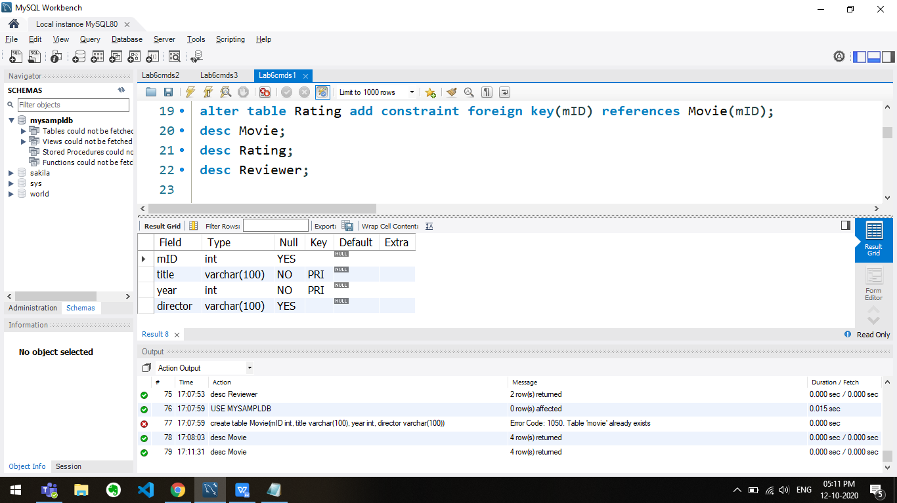

desc Rating;

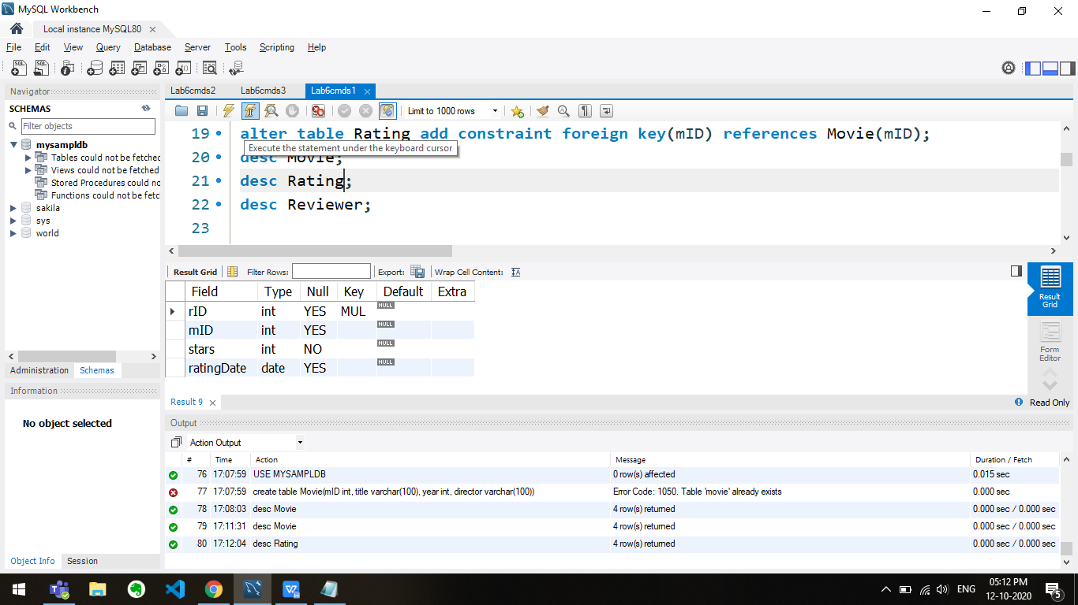

desc Reviewer;

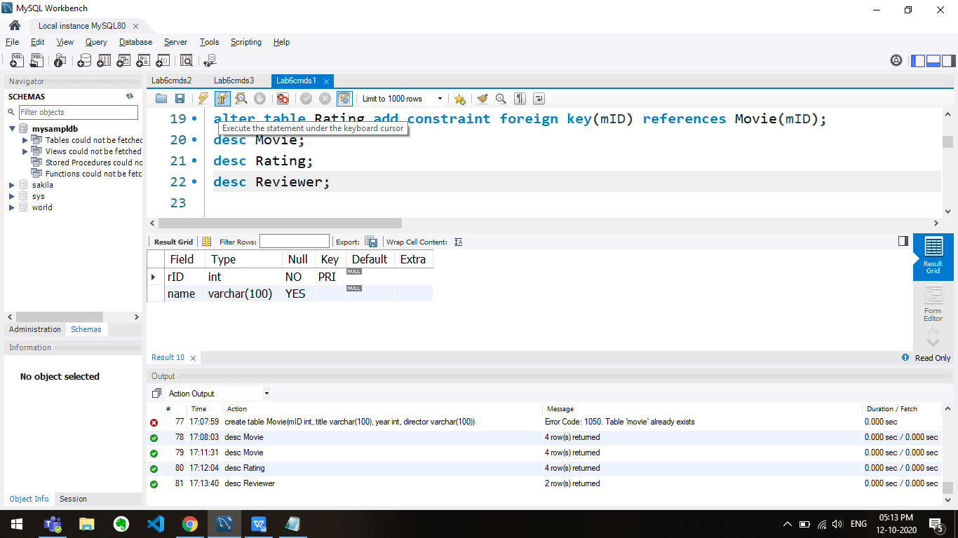

-- 2

insert into Movie values(101, 'Gone with the Wind', 1939, 'Victor Fleming');

insert into Movie values(102, 'Star Wars', 1977, 'George Lucas');

insert into Movie values(103, 'The Sound of Music', 1965, 'Robert Wise');

insert into Movie values(104, 'E.T.', 1982, 'Steven Spielberg');

insert into Movie values(105, 'Titanic', 1997, 'James Cameron');

insert into Movie values(106, 'Snow White', 1937, null);

insert into Movie values(107, 'Avatar', 2009, 'James Cameron');

insert into Movie values(108, 'Raiders of the Lost Ark', 1981, 'Steven Spielberg');

insert into Reviewer values(201, 'Sarah Martinez');

insert into Reviewer values(202, 'Daniel Lewis');

insert into Reviewer values(203, 'Brittany Harris');

insert into Reviewer values(204, 'Mike Anderson');

insert into Reviewer values(205, 'Chris Jackson');

insert into Reviewer values(206, 'Elizabeth Thomas');

insert into Reviewer values(207, 'James Cameron');

insert into Reviewer values(208, 'Ashley White');

insert into Rating values(201, 101, 2, '2011-01-22');

insert into Rating values(201, 101, 4, '2011-01-27');

insert into Rating values(202, 106, 4, null);

insert into Rating values(203, 103, 2, '2011-01-20');

insert into Rating values(203, 108, 4, '2011-01-12');

insert into Rating values(203, 108, 2, '2011-01-30');

insert into Rating values(204, 101, 3, '2011-01-09');

insert into Rating values(205, 103, 3, '2011-01-27');

insert into Rating values(205, 104, 2, '2011-01-22');

insert into Rating values(205, 108, 4, null);

insert into Rating values(206, 107, 3, '2011-01-15');

insert into Rating values(206, 106, 5, '2011-01-19');

insert into Rating values(207, 107, 5, '2011-01-20');

insert into Rating values(208, 104, 3, '2011-01-02');

select * from Movie;

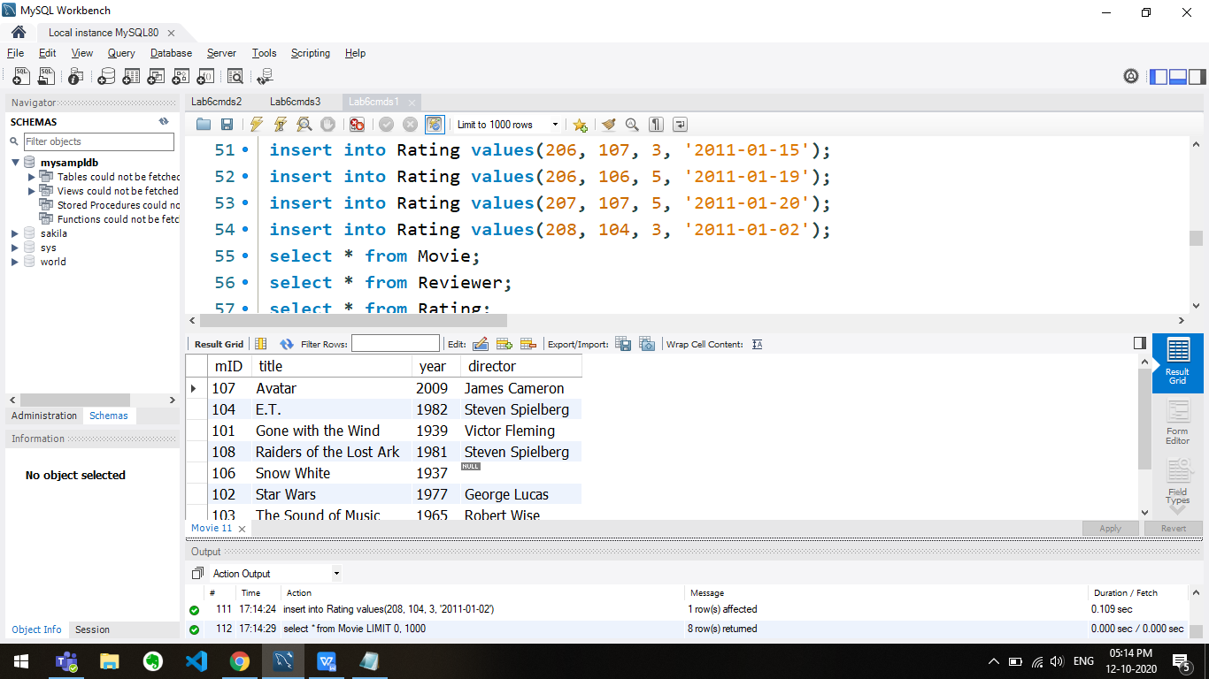

select * from Reviewer;

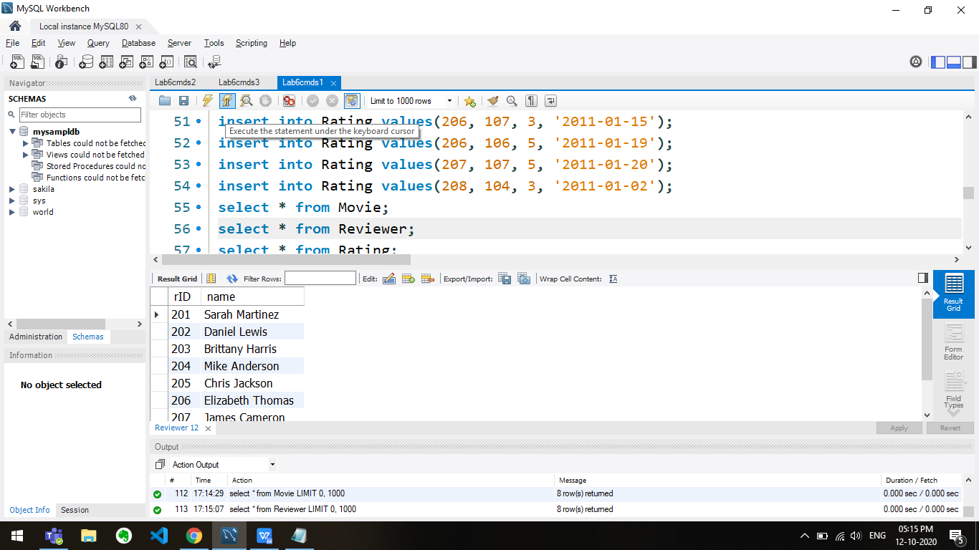

select * from Rating;

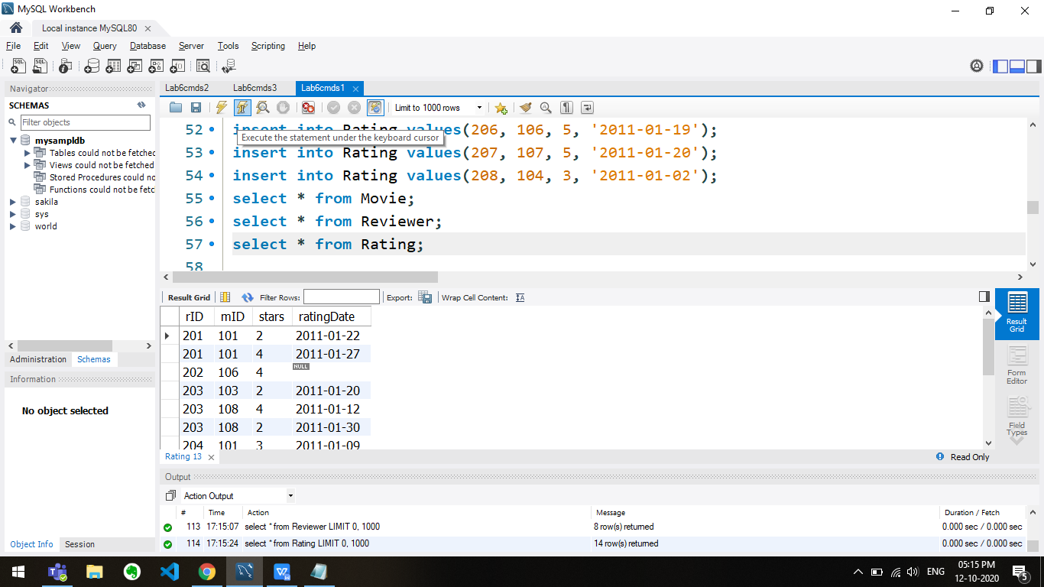

-- 3

insert into Reviewer values(209, null);

-- 4

insert into Rating values(201, 101, null, '2011-01-22');

-- 5

insert into Rating values(201, 101, 7, '2011-01-22');

-- 6

insert into Rating values(201, 101, 7, '1999-01-22');

-- 7

insert into Movie values(1000, 'Titanic', 1889, 'James Cameron');

-- 8

insert into Rating values(226, 107, 3, '2011-01-15');

-- 9

insert into Rating values(206, 157, 3, '2011-01-15');

-- 10

alter table Rating drop foreign key rating_IBFK_1;

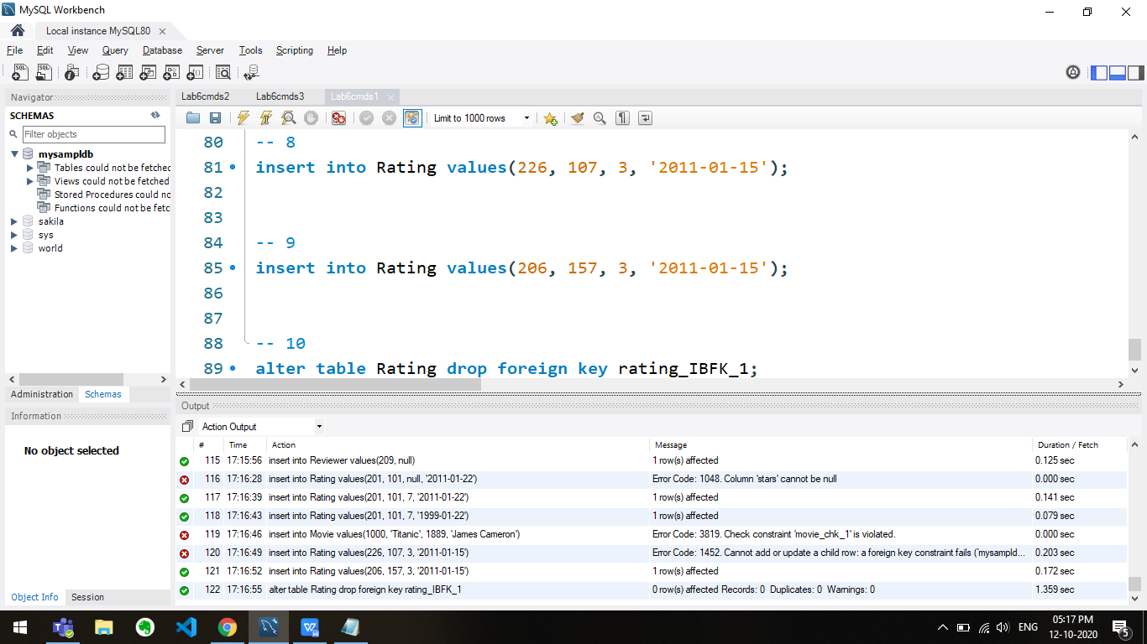

**Q2**

USE MYSAMPLDB;

CREATE TABLE BOOK(BID INT PRIMARY KEY,TITLE VARCHAR(100),PUBLISHER VARCHAR(100));

CREATE TABLE BOOK_AUTHOR(AID INT PRIMARY KEY,BID INT,AUTHOR_NAME VARCHAR(100),FOREIGN KEY (BID) REFERENCES BOOK(BID));

CREATE TABLE BORROWER(CARDNO INT PRIMARY KEY,NAME VARCHAR(100),ADDRESS VARCHAR(100),PHONE INT);

CREATE TABLE BOOK_LOANS(TRANSID INT PRIMARY KEY,BID INT,CARDNO INT,DATE_OUT DATE,DUE_DATE DATE);

INSERT INTO BOOK VALUES (100,'MATHS','SHARMA');

INSERT INTO BOOK VALUES (101,'ENGLISH','ALICE');

INSERT INTO BOOK VALUES (102,'SCIENCE','RAJU');

INSERT INTO BOOK VALUES (103,'SOCIAL','NEEL');

INSERT INTO BOOK VALUES (104,'HINDI','RAM');

INSERT INTO BOOK VALUES (105,'TELUGU','RAMHARAN');

INSERT INTO BOOK_AUTHOR VALUES (1,100,'KUMAR');

INSERT INTO BOOK_AUTHOR VALUES (2,101,'JOHN');

INSERT INTO BOOK_AUTHOR VALUES (3,102,'BRIJESH');

INSERT INTO BOOK_AUTHOR VALUES (4,103,'GURU');

INSERT INTO BOOK_AUTHOR VALUES (5,104,'RAHUL');

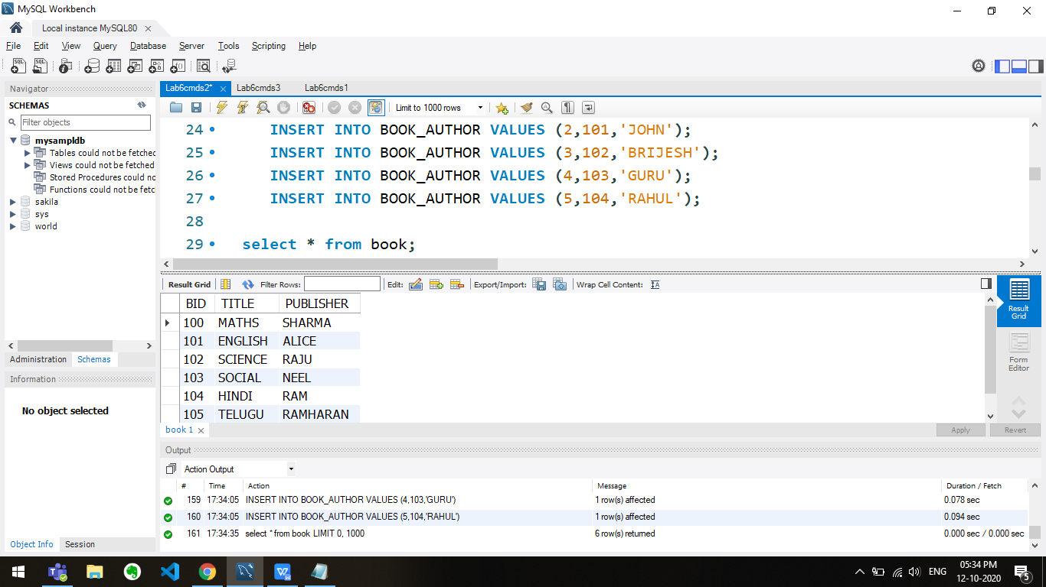

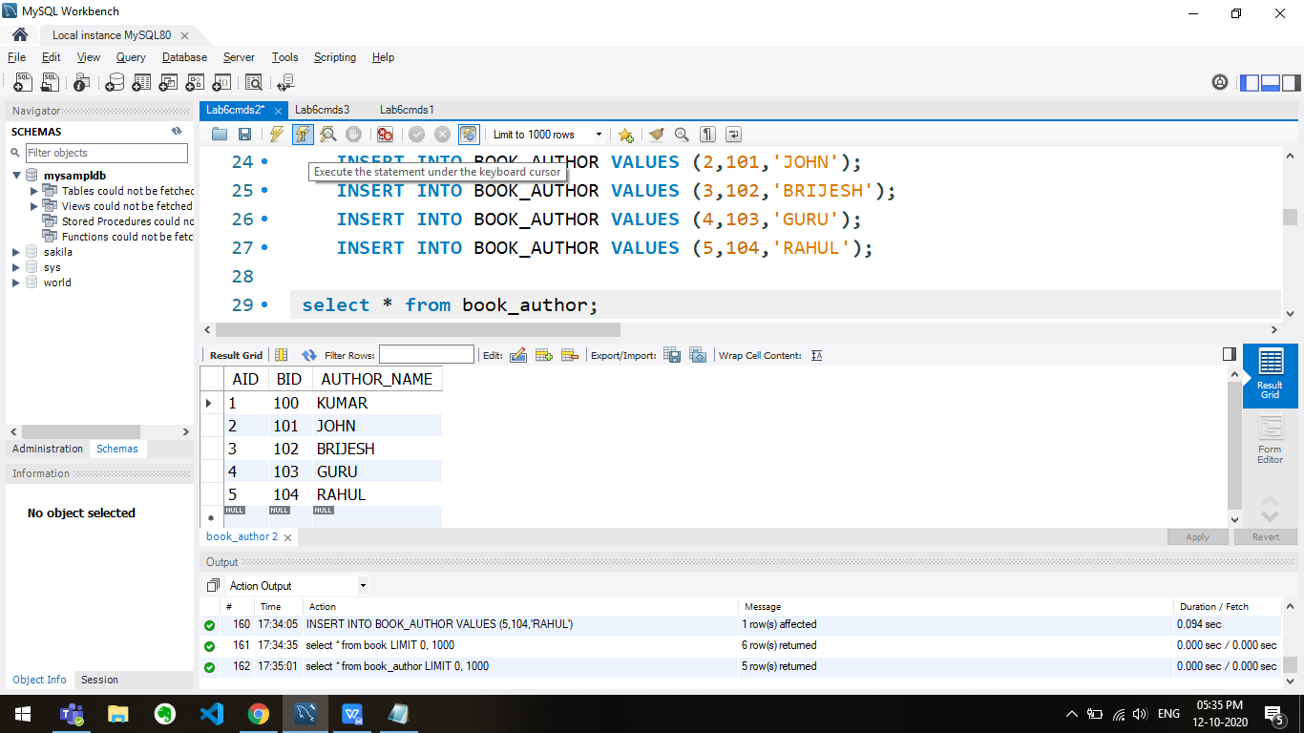

-- 3

UPDATE BOOK SET BID=6 WHERE BID=5;

-- 4

ALTER TABLE BOOKAUTHOR DROP FOREIGN KEY BOOKAUTHOR_ibfk_1;

-- 5

ALTER TABLE BOOKAUTHOR ADD FOREIGN KEY (BID) REFERENCES BOOK(BID) ON UPDATE CASCADE;

-- 6

UPDATE BOOK SET BID=6 WHERE BID=5;

-- 7

DELETE FROM BOOK WHERE BID=6;

-- 8

ALTER TABLE BOOKAUTHOR ADD FOREIGN KEY (BID) REFERENCES BOOK(BID) ON DELETE CASCADE;

-- 9

DELETE FROM BOOK WHERE BID=6;

-- 10

ALTER TABLE BOOKLOAN ADD FOREIGN KEY (BID) REFERENCES BOOK(BID) ON UPDATE RESTRICT ON DELETE SET NULL;

-- 11

insert into Borrower values ( 51 , "Ayush" , "Chennai" , 109823) , ( 52 , "Pinky" , "Madurai" , 903951) , ( 53 , "Harshit" ,"Mumbai" , 980980) , ( 54 ,"Nitin" , "Duabii" , 12323) , (55 , "Priyanka" , "Bangalore" , 99819);

insert into Book_loans values ( 1001 , 4 , 52 , "2020-01-31" , "2020-04-1") , ( 1002 , 3 , 52 , "2020-01-03" , "2020-08-01" ) , ( 1003 ,10 , 53 , "2020-09-01" , "2020-12-12") , ( 1004 , 5 , 54 , "2020-09-01" , "2020-12-12");

-- 12

DELETE FROM BORROWER WHERE CARDNO =1;

DELETE FROM BORROWER WHERE CARDNO =4;

-- 13

UPDATE BOOK SET TITLE="FAMOUS FIVE" WHERE BID=1

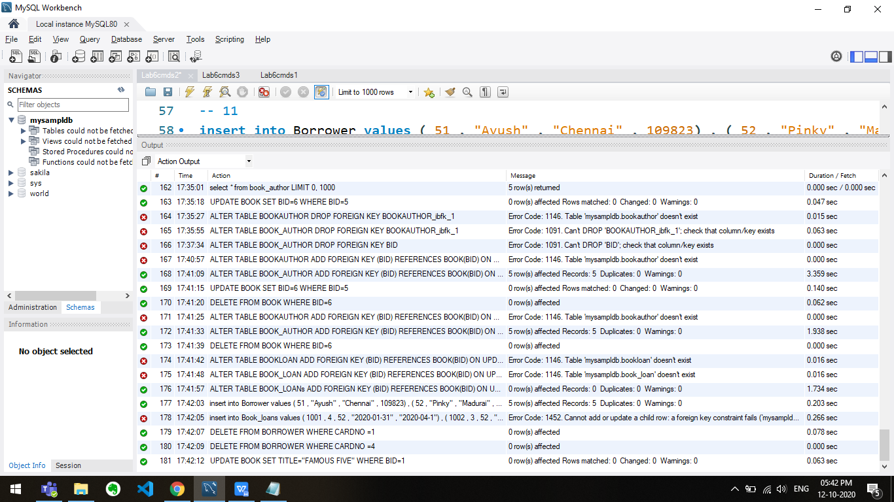

**Q3**

USE MYSAMPLDB;

DROP TABLE IF EXISTS OFFSITESECTION;

DROP TABLE IF EXISTS ENROLLEDIN;

DROP TABLE IF EXISTS SECTION;

DROP TABLE IF EXISTS STUDENT;

DROP TABLE IF EXISTS PROFESSOR;

DROP TABLE IF EXISTS COURSE;

CREATE TABLE COURSE

(

COURSENUM INT,

COURSENAME VARCHAR(100),

PRIMARY KEY(COURSENUM)

);

CREATE TABLE PROFESSOR

(

PROFNUM INT,

PROFNAME VARCHAR(50),

PRIMARY KEY(PROFNUM)

);

CREATE TABLE STUDENT

(

STUDENTNUM INT,

STUDENTNAME VARCHAR(50),

GPA INT,

PRIMARY KEY(STUDENTNUM)

);

CREATE TABLE SECTION

(

COURSENUM INT,

TERM INT,

SECTIONNUM INT,

PROFNUM INT,

PRIMARY KEY(COURSENUM,TERM,SECTIONNUM),

FOREIGN KEY(COURSENUM) REFERENCES COURSE(COURSENUM),

FOREIGN KEY(PROFNUM) REFERENCES PROFESSOR(PROFNUM)

);

CREATE TABLE ENROLLEDIN

(

COURSENUM INT,

SECTIONNUM INT,

STUDENTNUM INT,

TERM INT,

PRIMARY KEY(COURSENUM,SECTIONNUM,STUDENTNUM,TERM),

FOREIGN KEY(COURSENUM) REFERENCES SECTION(COURSENUM),

MARK INT

);

CREATE TABLE OFFSITESECTION

(

COURSENUM INT,

TERM INT,

SECTIONNUM INT,

PRIMARY KEY(COURSENUM,TERM,SECTIONNUM),

FOREIGN KEY(COURSENUM) REFERENCES SECTION(COURSENUM),

LOCATION VARCHAR(100)

);

